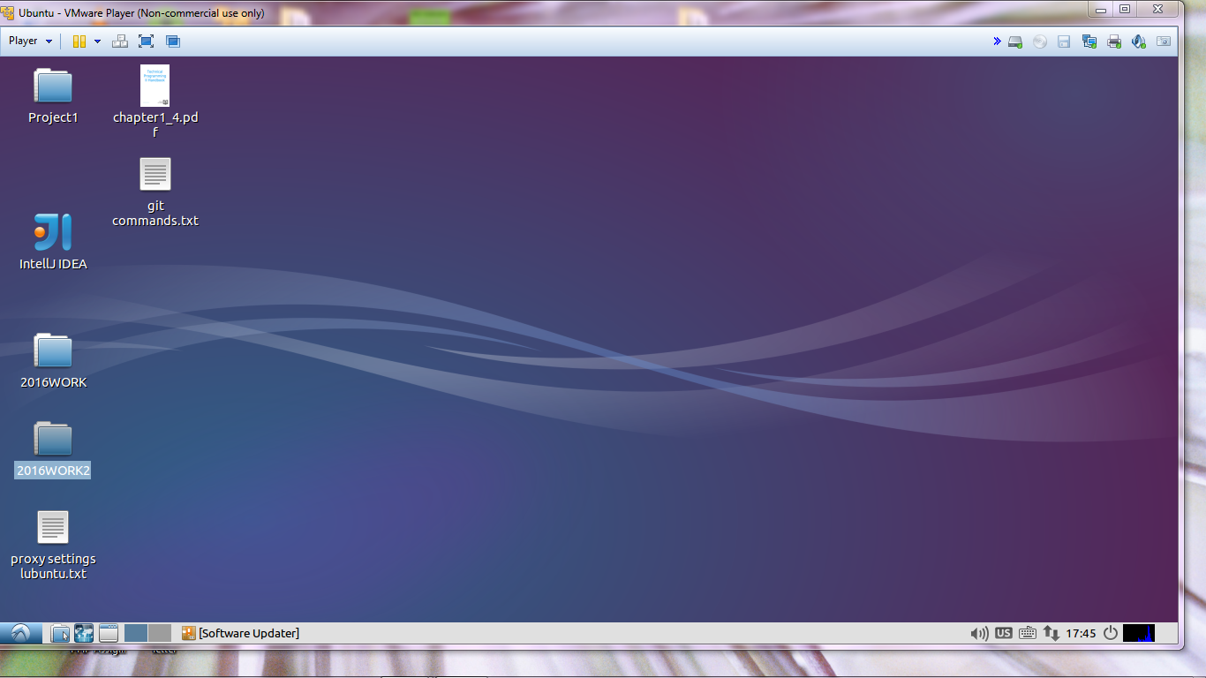

Git repo created

File created and the status is checked and it is green cause it exists

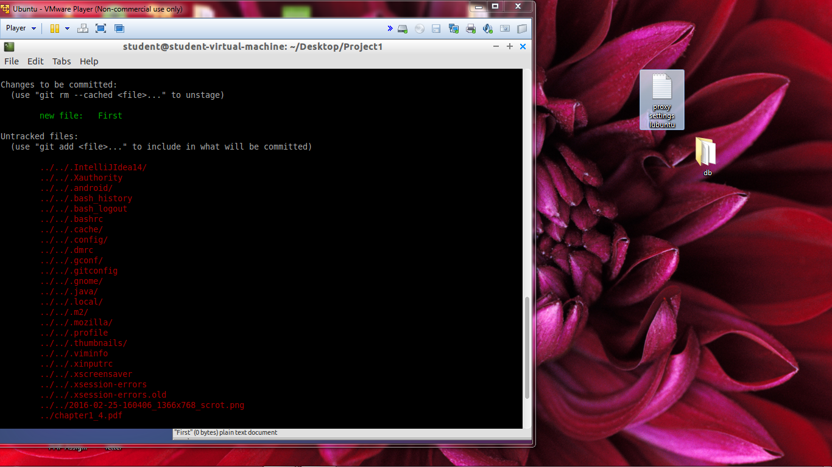

File is green because it is being tracked and it exists

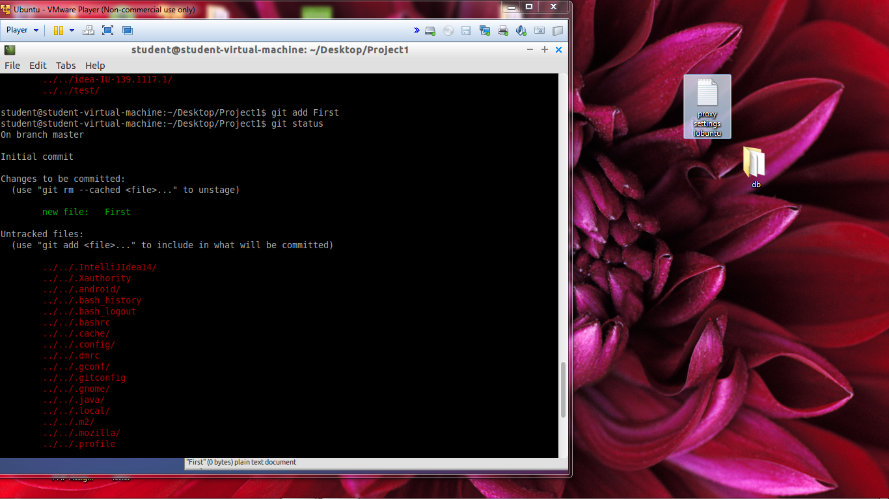

File is committed as show above green means it has been save or commited



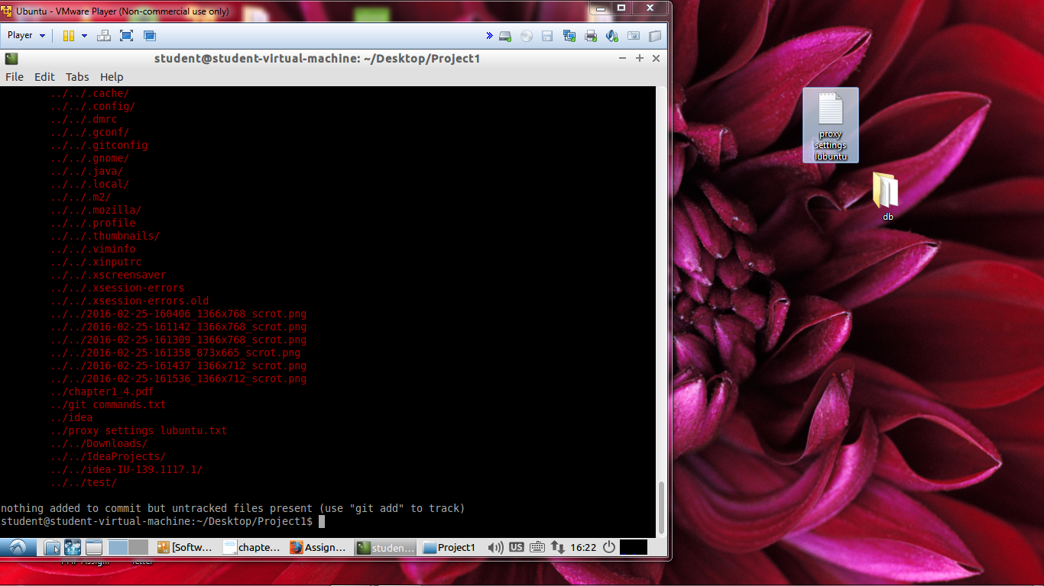

The 3 file have been created and it exists but has not been commited that’s why it is red

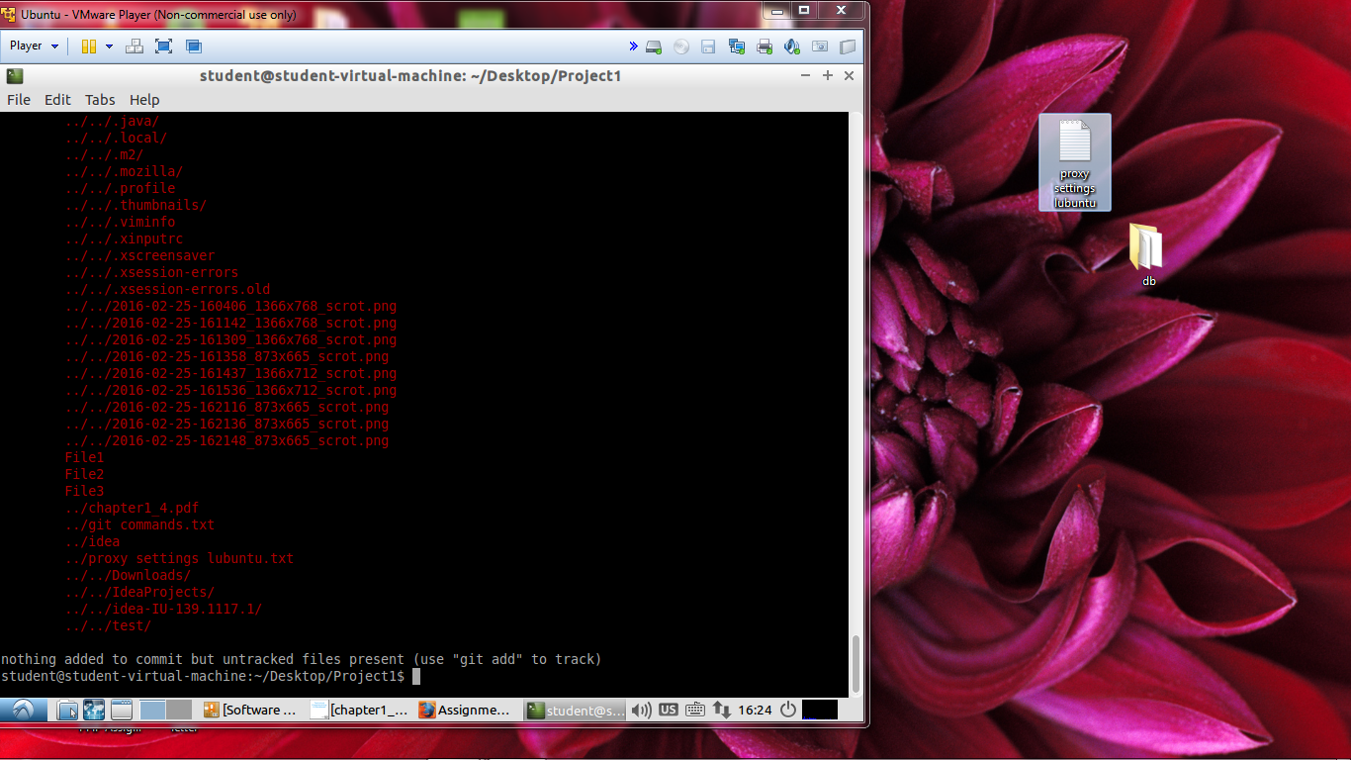

The files has been edited and has been commited that’s why it is green

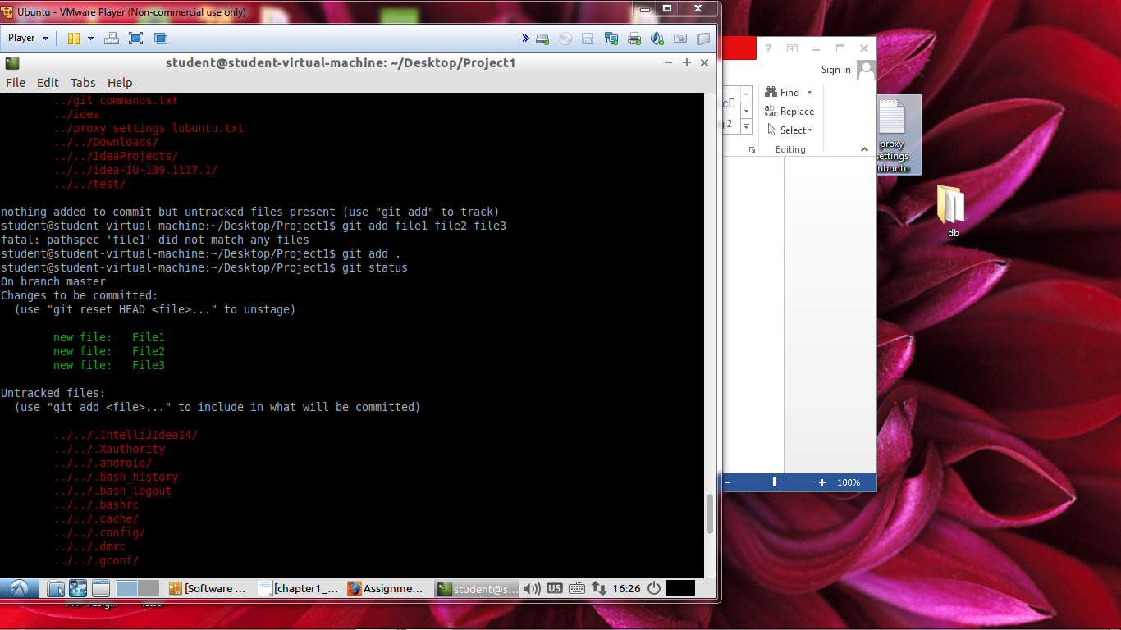

All files are being tracked and have been commited

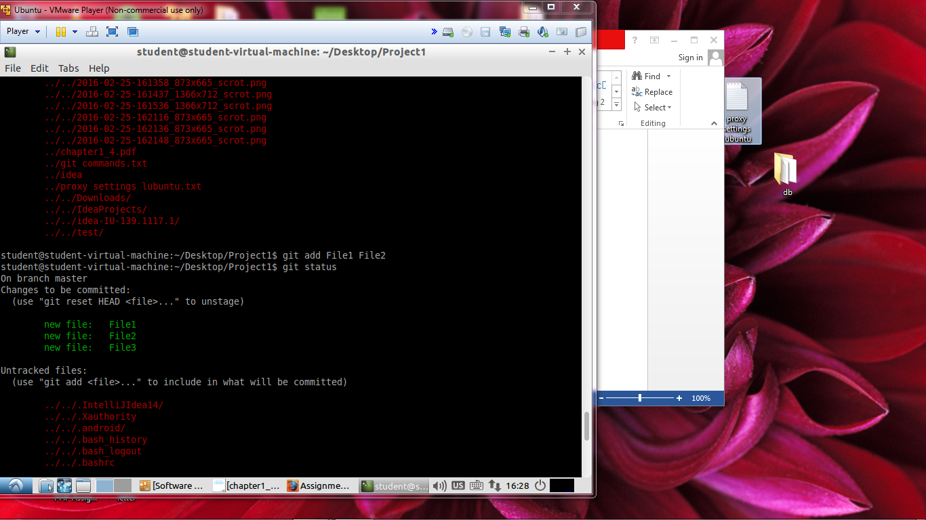

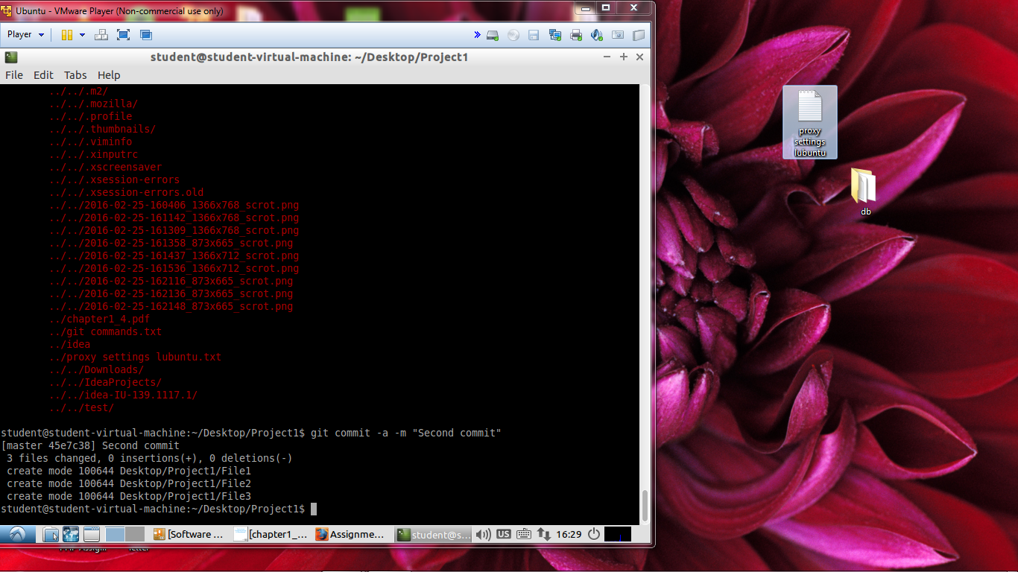

Short status output

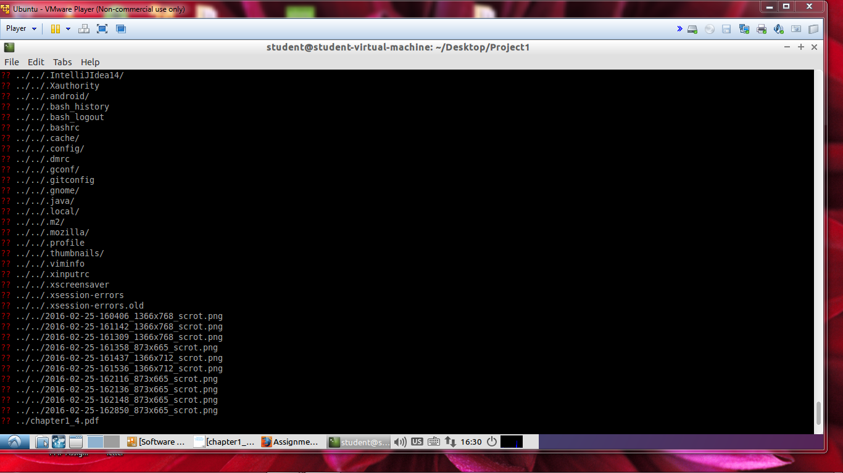

The file has been ignored by git that is why the file is in red

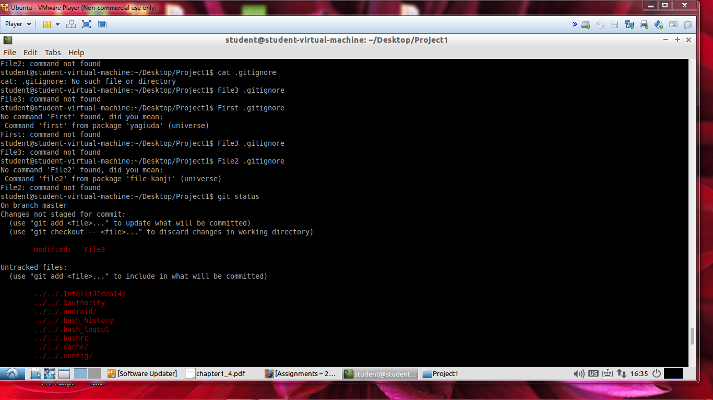

xi. Get the status of the changes that you made to your repository



One of the files has been removed

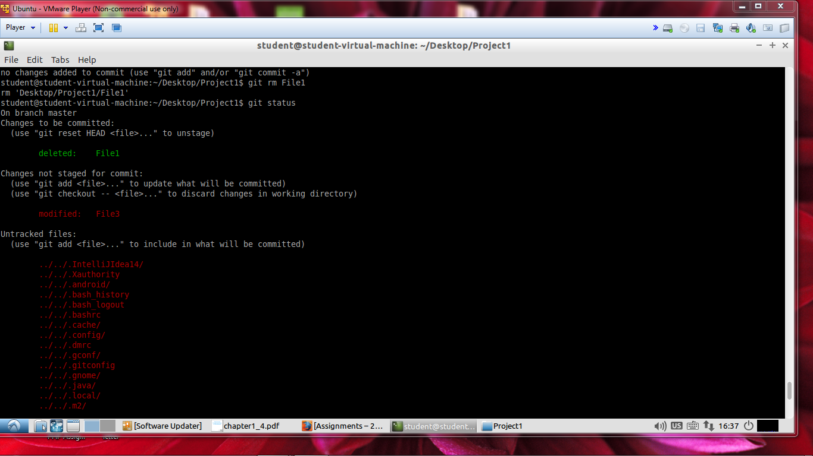

The history log

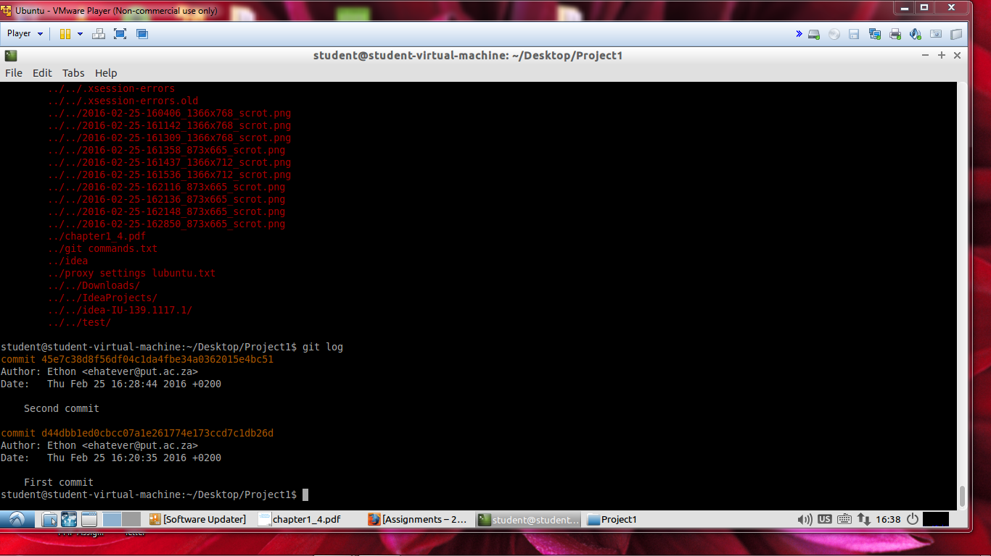

3. This section requires you to use your GitHub account that you just created

i. In your GitHub account, create a repository and clone it onto your PC and ensure that you put it in a different directory

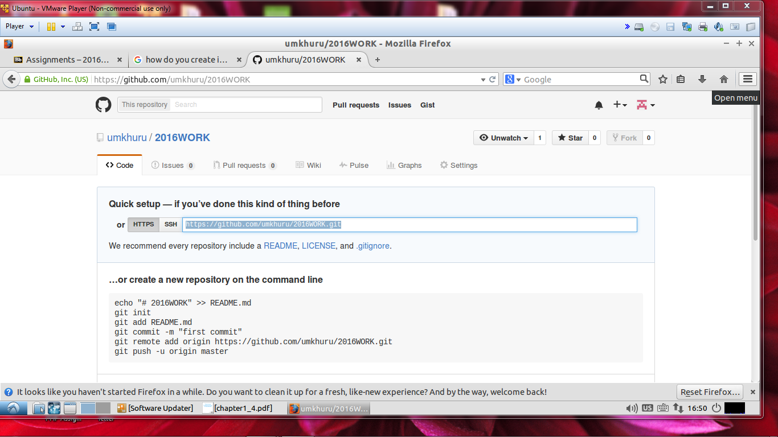

ii. Show your full remotes on your local machine using a git command and take snapshot

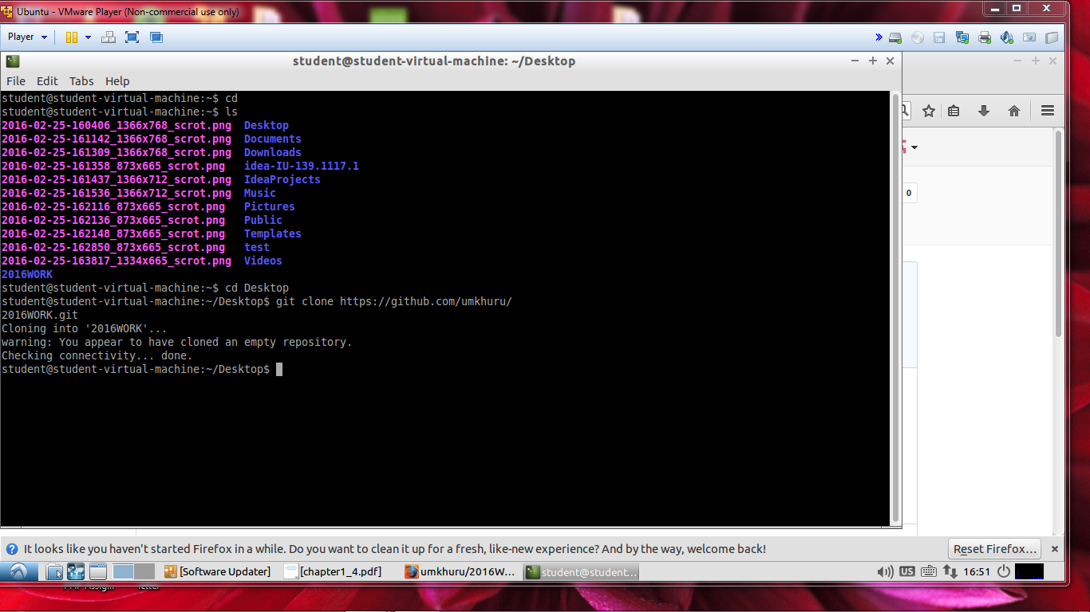

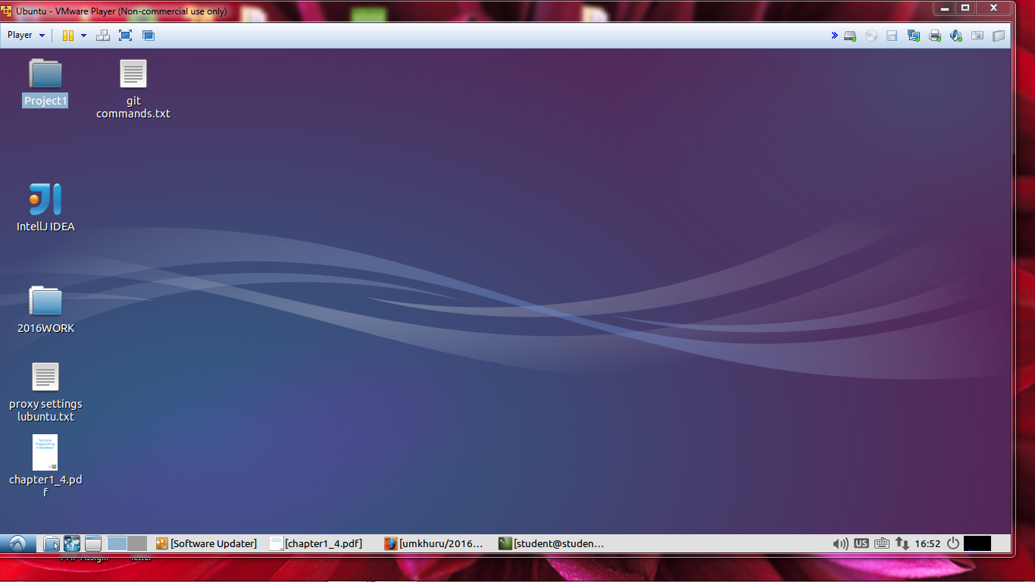

ii. Add a file to your repo and push he file to GitHub

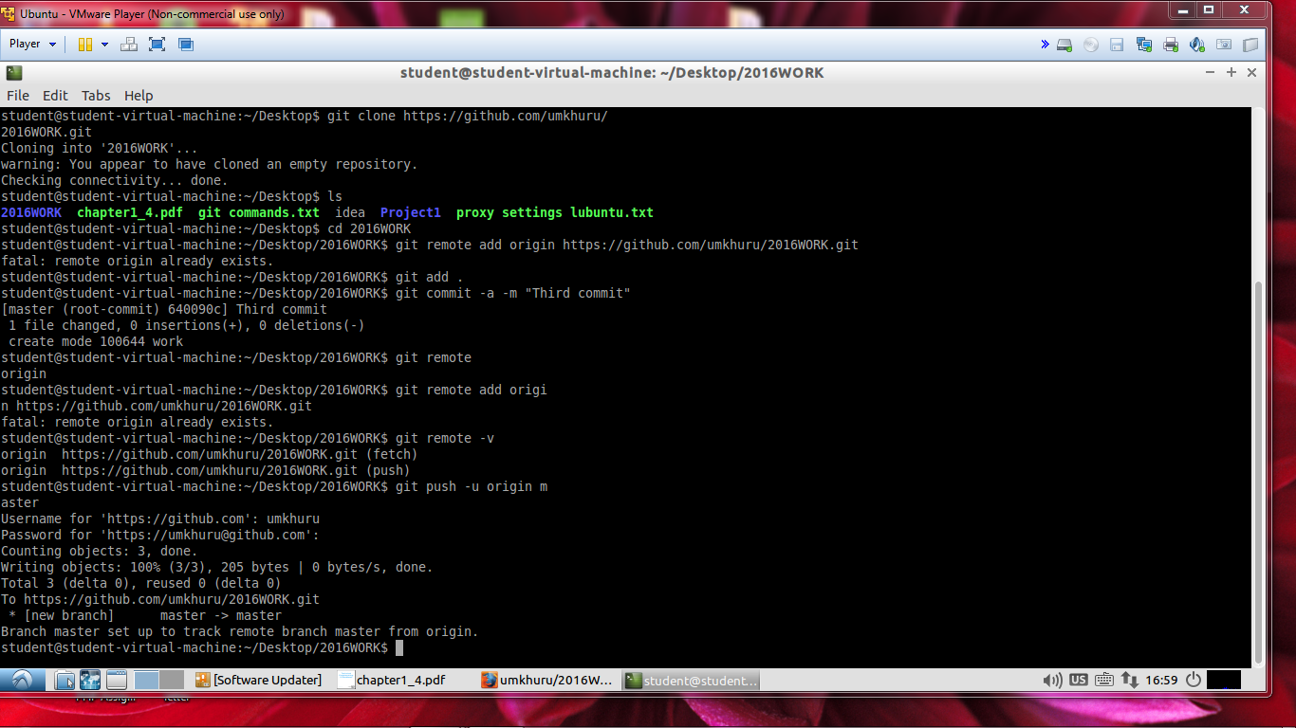

iii. Create another Git Repo and add any other file to the remote repository and again show full remotes for your repository

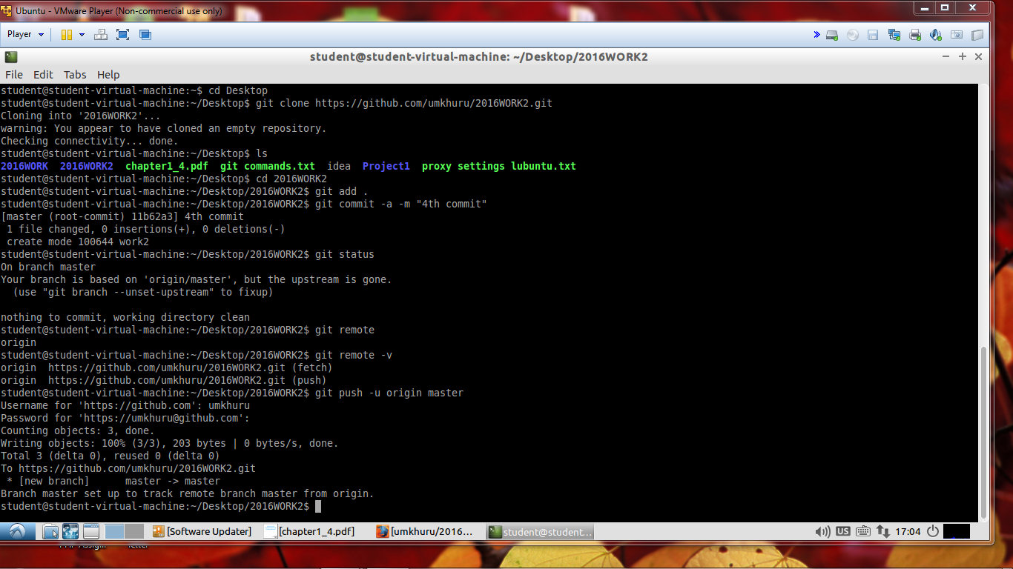

iv. Get the contents of the remote repository in and merge it into your local repo

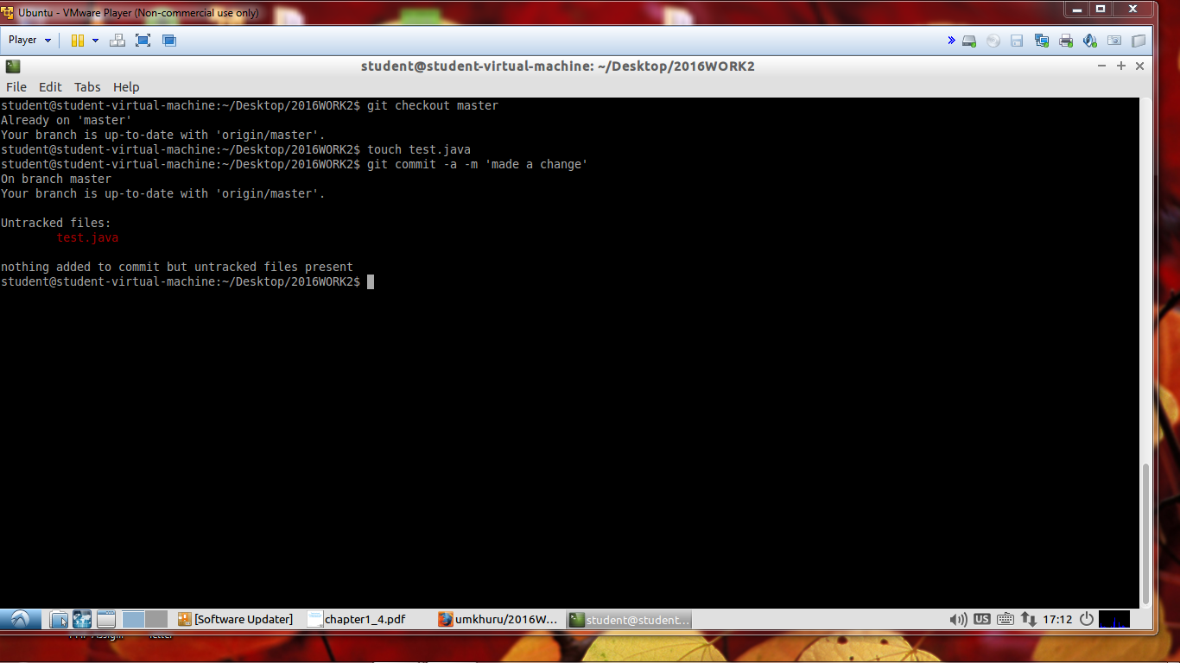

v. Create another git repository and add another repo repository.

vi. Get the content using using one git command to so that the result is a fully merged repo

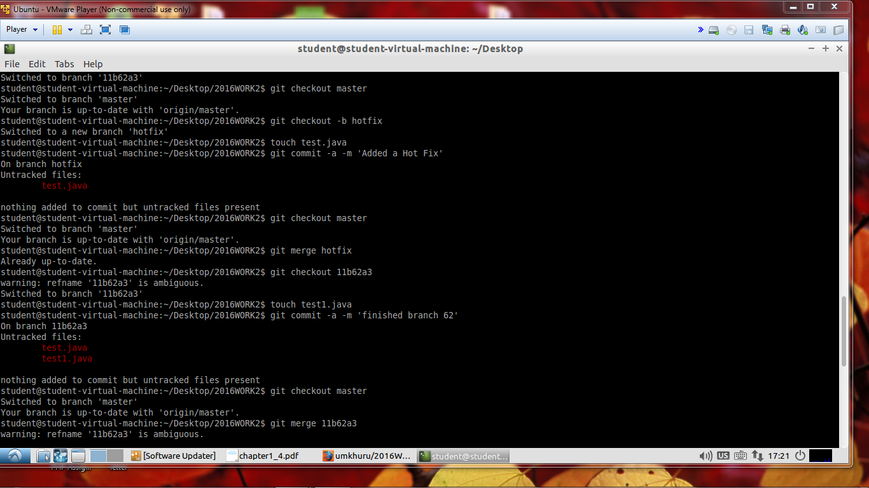

vii. Remove the remote from your repository

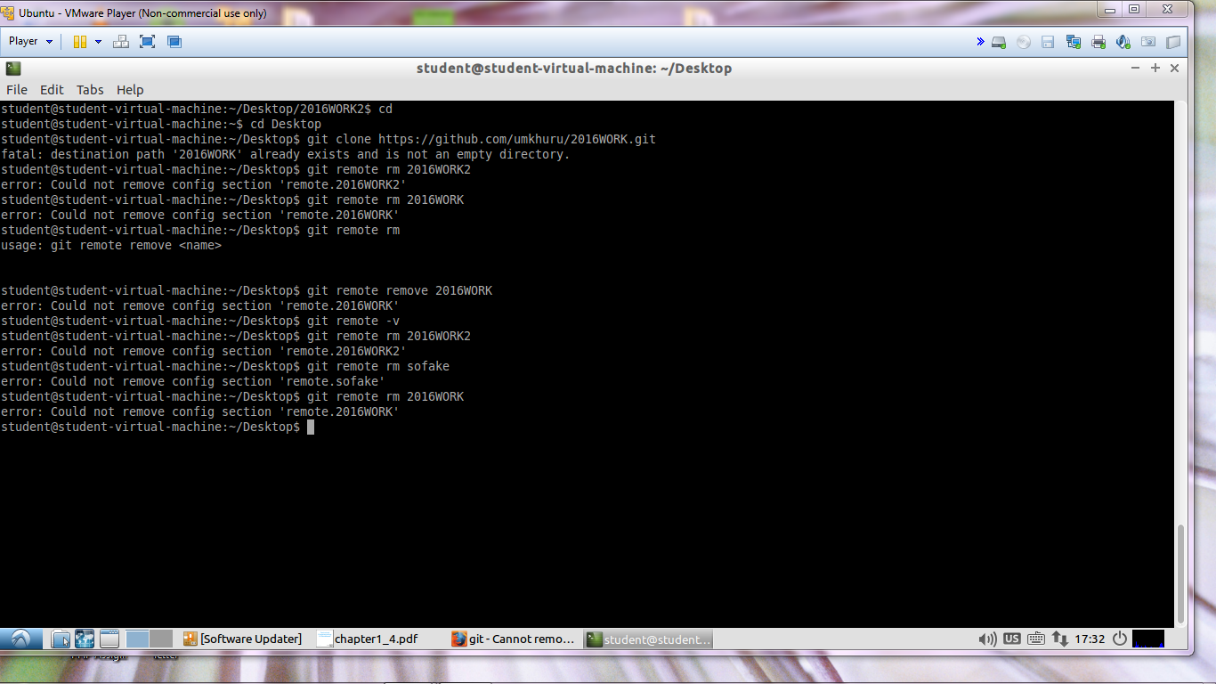

4. Demonstrate the ability to tag your repo with version numbers and commit these them to gitHub

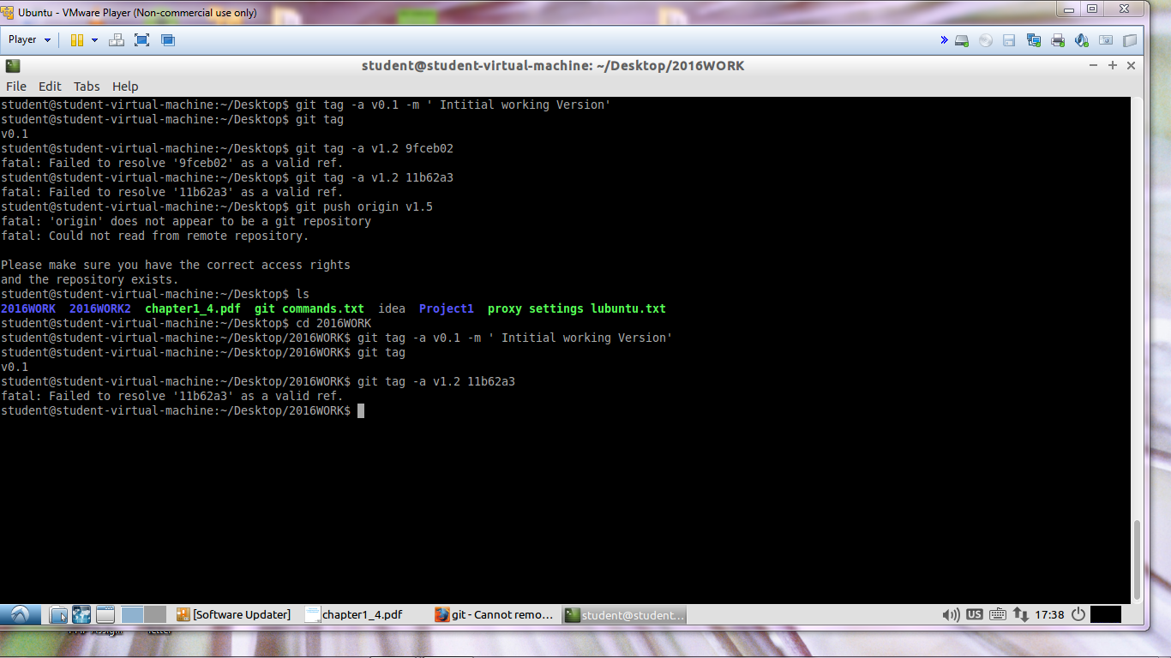

5. Read the chapter on branching and demonstrate the ability to create branches and integrating the merge. GitHub will produce graphs for you.

6. Demonstrate Rebasing on another repo that you create on GitHub